Streambank Stabilization Project along Calumet Union Drainage Ditch
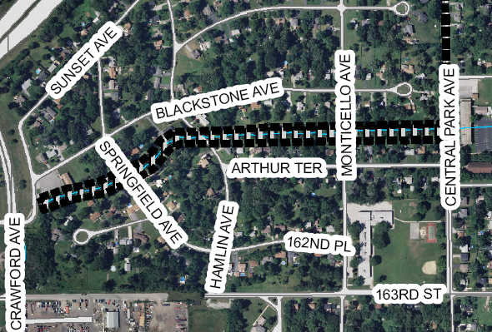

Project Number: 10-882-BF
Service Area:
Location: Markham, IL
Engineering Consultant: Michael Baker, Jr., Inc.
General Contractor: To be determined
Estimated Construction Cost: $2,475,513
Contract Award Date: October 2020*
Substantial Completion Date: January 2024*

Project Description: This project will stabilize approximately 3,559 linear feet of the Calumet Union Drainage Ditch, between Sunset and Central Park Avenues, in the City of Markham.
Project Justification: Safety/Regulatory. This project will protect structures and infrastructure in imminent danger of failure from active streambank erosion and flooding.
Project Status: This District is preparing to advertise project for bidding.
This project is funded under the Capital Improvements Bond Fund.
*Information shown is estimated.

